C32 Performance Framework: Test Harness Design Using Test Execute Framework
Security Classification: | Internalinternal | Team/Department: | Networking Team
Document Reference: | PREQ890 Test DesignSGL.GT0280.xxx_PREQ890 Test Design.doc | Author(s): | Jose Thachil
Status: | For Review | Owner(s): | Networking Test Team Networking Test Team
Version: | 0.40.3 | Approver(s | Feroz uddinFeroz uddin
Last Revised Date: | 01/03/200616/02/2006 |  | Feroz uddinFeroz uddin

Introduction

Purpose and Scope
This document outlines a design approach for multithreaded C32 performance tests.
The objective of this document is to describe test design details of C32 Performance Tests within ser-comms subsystem. The target audience is anyone in networking dealing with C32 performance tests. The scope of this document specifies the test harness design using test execute framework.
The reader should refer the Test specification document [R1] Section 2 for a description of the test environment, and to Section 4.1 for a description of the individual test cases. Also refer the document [R2] to get more details about the Test Execute Framework (TEF).

Test Harness Design

Overview
The test harness is designed to run on a single device emulator or reference board. The test harness utilises the Test Execute Framework as its basis, allowing for the tests to be easily automated.
This framework can be used to perform single threaded as well as Multithreaded C32 Performance tests which loads the different CSY’s in each client thread.

Each client thread can be configured using the values stored in the ini file. The ini file format is detailed under section 2.4.1.A parse function called ProcessNextDescriptionL() is used to validate the fields in the ini file. Each client thread details(thread name, thread priority etc) from the ini file are populated in a class called TThreadData which contains different member variables to store execution time of a thread, result of a test case etc. A series of test cases are then run simultaneously to measure the performance. The log file displays the performance results of each client thread.
Each multithreaded test case should be derived from CperformTestTasks which contains two virtual functions Init() and PerformTask(). The Init() function does all the required initialization corresponding to each CSY. The Init() function can be used to load the CSY’s and connect to RcommServ.The PerformTask() function can be used to perform respective tasks (Read/Write operations) specific to each CSY.
A global semaphore is implemented in the framework to block the client threads. The semaphore will be in wait state until all the CSYs are loaded in each client thread. On signalling the semaphore read/write operations are performed through those loaded CSYs concurrently. In this way different client threads can talk to C32 in pseudo-simultaneous way.

Class Diagram
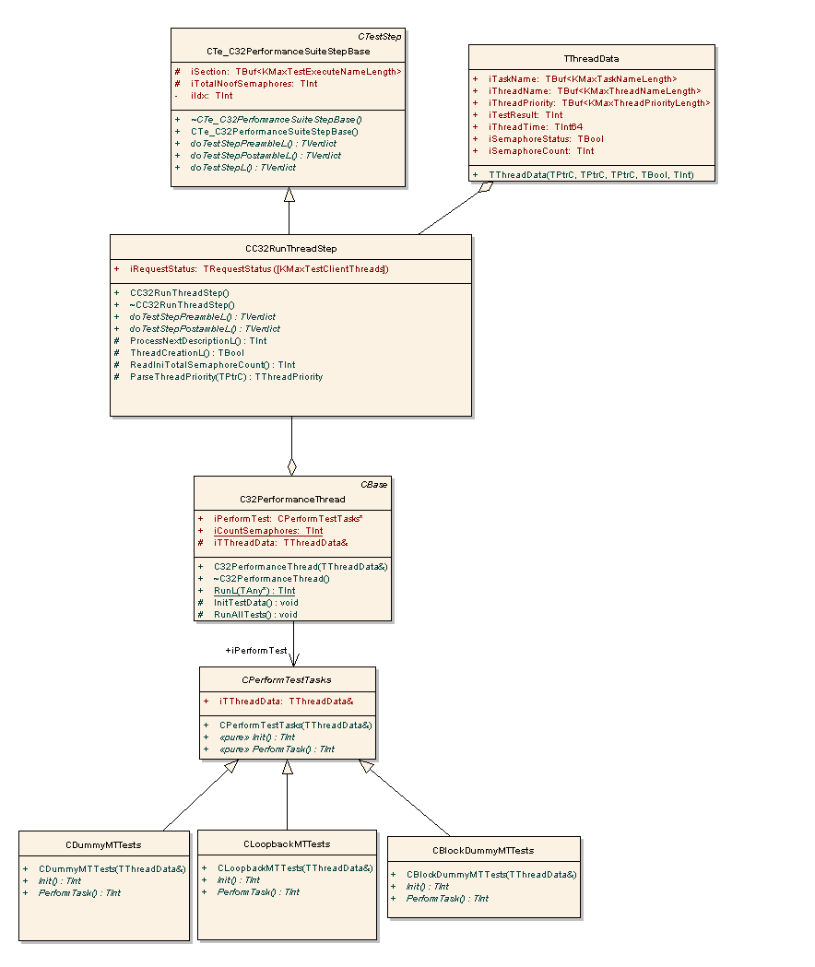

Sequence Diagram

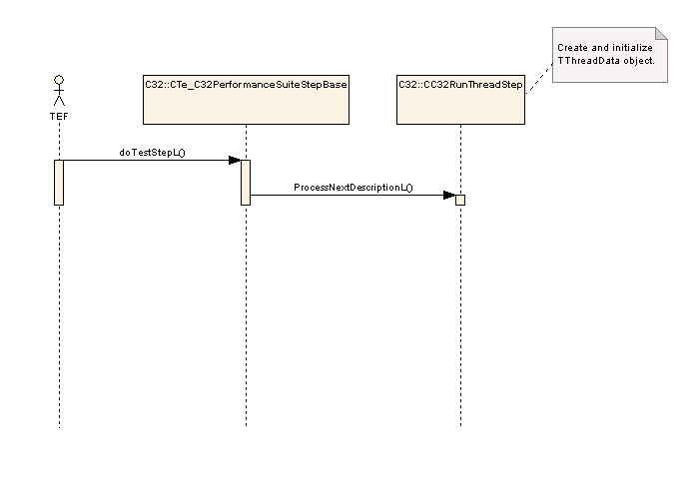

Figure 1 – Creates and initialize TthreadData object
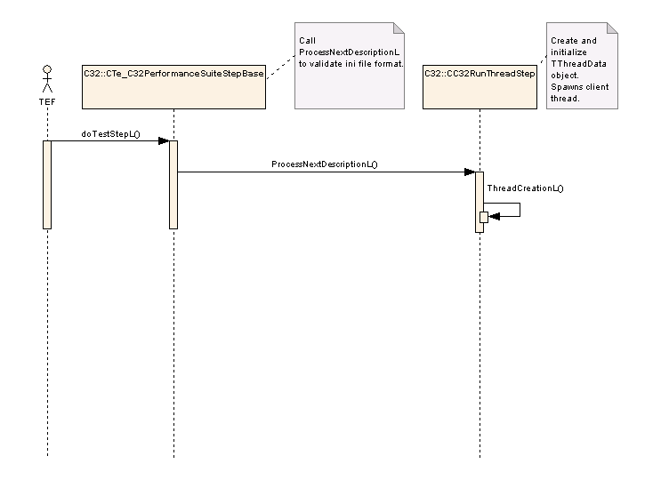

Figure 2 – Spawns a client thread

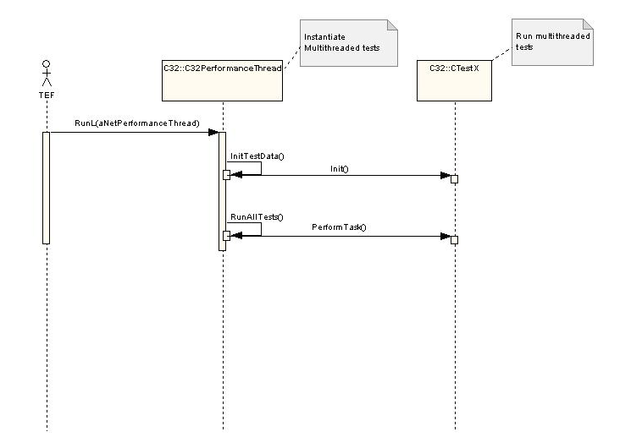

Figure 3 - Run multithreaded Tests

Test Harness Components

Test Step

Script File

Parser INI Function
INI File

(Contains input parameters to
populate TThreadData)

INI File
The ini file contains the input parameters for all the test cases. Each test case will have a separate ini file. Based on the type of test case, the parameters of the ini file data needs to be changed accordingly. The framework adds index to the section name ‘Thread’ which iterates through a loop until it finds the last section name. It sets the test result to fail if any of the mandatory fields in the ini file are missing with an error message.
The ini files reside in z:\testdata\configs\
The path of the ini file will be given in the script file.
The basic structure of the ini file for MT tests is as below.
[Thread0]
Name=Thread0
Priority=EpriorityNormal
Task=Test0
Semaphore=True

[Thread1]
Name=Thread1
Priority=EpriorityNormal
Task=Test1
Semaphore=True

[Thread2]
Name=Thread2
Priority=EpriorityNormal
Task=Test2
Semaphore=True

[Thread3]
Name=Thread3
Priority=EpriorityNormal
Task=Test3
Semaphore=True

INI File Traceability Table

Parameter Name | Type | Optional | Relevant Section | Description
Name | String | No | Threadxx | Displays name of the client thread.
Priority | String | No | Threadxx | This value can be used to set the priority of each client thread.
Task | String | No | Threadxx | This field corresponds to each MT test case name.
Semaphore | Bool | No | Threadxx | This field can be either True or False.If this is set to True,a global semaphore will be used in the client thread. This is used to block the client threads(which will in wait state) until all the CSYs are loaded.If this field is set to False, the client thread will run to completion irrespective of other CSYs are loaded or not.(i.e. each client thread runs independently)  If True -> Semaphore is used in the client thread.  If False-> Semaphore is not used in the client thread.

Script File
The Script file contains all the test cases. The format of the script file follows as defined in the TEF.
The script files reside in z:\testdata\scripts\

Test Step Components
Class Name | Te_C32PerformanceSuiteServer
Description | The Te_C32PerformanceSuiteServer object is the Test Server, which instantiates the C32RunThreadStep test step object.

Class Name | Cte_C32PerformanceSuiteStepBase
Description | Test Step follows the general Test Execute preamble, test step, postamble approach to execute the test steps  To implement a single threaded test case, derive a class from the Cte_C32PerformanceSuiteStepBase which is derived from CtestStep. Override the virtual functions doTestStepPreambleL, doTestStepPostambleL, doTestStepL accordingly. Please refer the document [R2] for more details.
doTestStepPreambleL | -do nothing-
doTestStepL | This function invokes ProcessNextDescriptionL() to validate the ini file format and returns the test result (EPass or EFail) to TEF.
doTestStepPostambleL | -do nothing-
ProcessNextDescriptionL | Overridden in derived class CC32RunThreadStep
ThreadCreationL | Overridden in derived class CC32RunThreadStep
Expected result | KErrNone

Class Name | CC32RunThreadStep
Description | This class is used to spawn each client thread. The performance result is logged to a HTML file.
doTestStepPreambleL | -do nothing-
doTestStepL | -do nothing-
doTestStepPostambleL | -do nothing-
ProcessNextDescriptionL | This function validates the ini file format (used in MT tests) and populates the class TThreadData.
ThreadCreationL | This function is used to create each client thread.
ReadIniTotalSemaphoreCount | Finds semaphore count from the ini file.
Expected result | KErrNone

Class Name | C32PerformanceThread
Description | This class is used to instantiate and execute the multithreaded tests. Each multithreaded test will be loaded in different client threads.
InitTestData | This function creates objects of multithreaded tests and calls Init () to initialize test data.
RunAllTests | Run all the tests loaded in different client threads.
RunL | Each client thread starts executing from the RunL function
Expected result | KErrNone

Class Name | CperformTestTasks
Description | Each multithreaded tests should be derived from this class.
Init | This function can be used to initialize test data
PerformTask | This function can be used to run the tests.
Expected result | KErrNone

Class Name | TThreadData
Description | This class is used to store the client thread details such as thread name, thread priority, test result, thread execution time etc.
Expected result | KErrNone

Other points to Note
- Based upon the test case and the results that we get, a decision is being taken whether to pass the test or fail the test.
- The same teststep is used for testing different test cases. Each test case will have its one ini file and the ini file name has to be entered correctly in the script file.
- The data to be entered in the ini file has to be in the same format as shown in 2.4.1

Assumptions and Risks
The following statements have been assumed to be true during the development of this test harness design document:-
- All test equipment and tools including the reference boards are available and fully functional.
- No benchmark was decided to compare the performance between old C32 code and new C32 code at the time of writing this document.
- The amount data to be transferred through the Csys was not stated in the requirement.

Further Information

People
Role | Person / People
Reviewers | Stephen Burden, Trudie Woods
Contributors | Jose Thachil
Distribution | Networking team

References
No. | Document Reference | Version | Description
[R1] | Draft | 0.5 | This document is to explain the PREQ890 Test specification. This document is available in /ser-comms/c32/Test/TE_C32/documentation/
[R2] | SGL.PR0088.301 | 1.7 | Test Execute Framework Functional Description. This document is available in /master/common/testtools/TestExecute/Documentation/

Glossary
The following technical terms and abbreviations are used within this document.
Term | Definition
CSY | Communication System
TEF | Test Execution Framework
MT | Multi Threaded
ST | Single Threaded

Document History
Date | Version | Status | Author | Description
28-02-2006 | 0.1 | Draft | Jose Thachil | First draft
01-03-2006 | 0.2 | For review | Jose Thachil | Sent for review
06-03-2006 | 0.3 | For review | Jose Thachil | Updated as per Steve’s review comments.
03-07-2006 | 0.4 | For review | Jose Thachil | Updated as per review comments.

